1. R Project-Prepare a dataset and perform k-means clustering.

**Description:**

Here we tried using the iris data set and performed the k means clustering on it. The k means clustering is an unsupervised learning algorithm which forms clusters and distributes the sample sets into the respective clusters based on the parameters of the sample. Here sepal length/width and petal length/width were used to classify the given data set.

Below is the attached screenshot of the results of the k means clustering.

**Screenshots:**

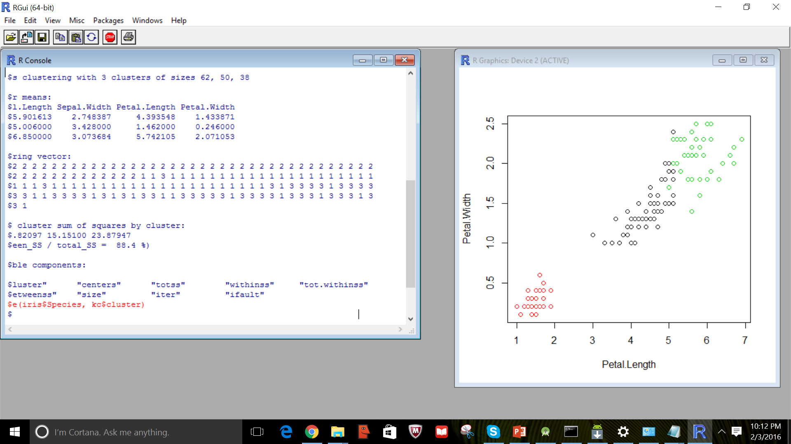

1. Robo Me and Watch App-Create a Robo Me and Watch App that uses weather or any API of choice.

**Description:**

I have created a watch app using Android studio which uses speech to text API. When clicked on the Mic icon in my phone, there appears a google speech to text service. When you spoke a sentence, it is recognized by speech to text service and converts it into a text. This text is then displayed on the smart watch as a notification. Please find the screenshots below.

**Screenshots:**

